SE322 – Software Design and Architecture
Project Description
Project Deliverable 1: (30/09/2026)[ 40%]
Students need to group themselves into a set of groups of no more than 5 students per group. Choose a project for your team and work on the requirements (SRS). You could use the project and the document developed in any of your previous courses, e.g., SE311 course. Project total score is 100 then will be converted 15% as per the syllabus.
2 (4+1 View Model):
you should do the following.
- You will adopt the 4+1 model to design your software architecture and the corresponding diagrams and document all your work in a design document.
- If you are using the diagrams you developed for other courses, revise them, and submit a detailed version of those diagrams. (Will provide you with an outline soon)
- Document your work in the Software Architecture Design (SAD) that should use the following template/outline:
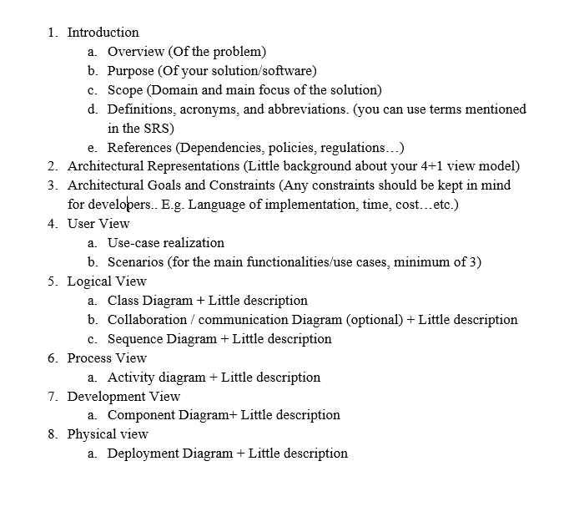

Project Deliverable -2 (Architecture Documentation): 10/10/2026 [ 20%]
In this phase you should do the following.
1. Identify 3-4 important quality attributes related to your project.
2. Draw and document the scenarios for your quality attributes.
3. Decide which architectural style is appropriate for your project, discuss that style in detail, why you chose it, and how you implement it on your project.
Project Deliverable-3 (Software Design Documentation): 25/10/2026 [20%]
In this phase you should do the following.
- Choose at least three design patterns to be implemented in your project.
- Justify your choices. The product here is the SDD.

Project Deliverable-4 (Validation and Presentation): Submission [04/11/2026] [ 20%]
Validation: Review and validate your design document to make sure that you fulfilled all necessary design decisions.
* Group leaders are the ones who should submit the deliverable on behalf of their group members.

